Decentralized Id by Authnull

AuthNull provides decentralized Id based authentication solutions for Legacy devices.

What is Decentralized Id and why does it matter?
A decentralized identity approach helps users and organizations with the resources they access transparently and securely, in an identity trust fabric. People control their own identity through wallet based credentials.

A Decentralized identity solution comes with the following advantages

User owns the Identity | Credentials are managed by the user | Standards based
The user owns the individual identity on their wallets as opposed to a centralized identity and access management solution | All credentials are managed by the user using standards based verifiable credentials | W3C Verified credentials and in compliance with NIST Special Publication 800-63-3

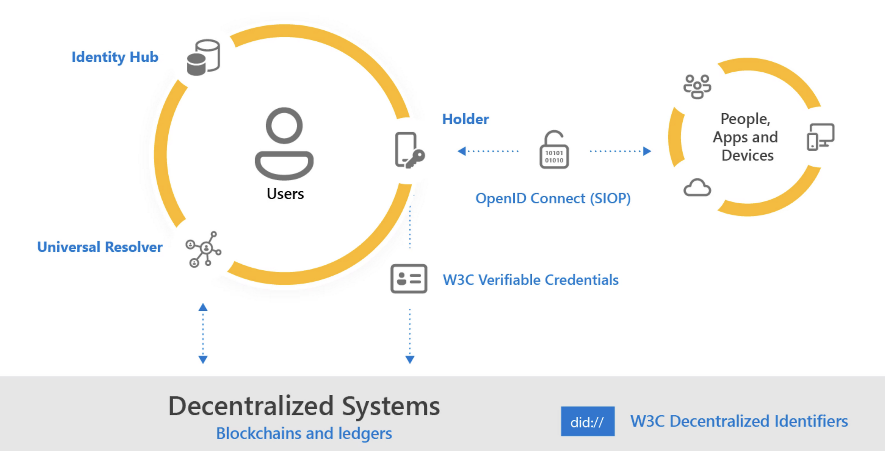

Why the need for digital identity
Centrally managed credentials are prone to attacks and hacks.
We believe a standards-based Decentralized Identity platforms can unlock a new set of experiences that give users control over their data—and deliver a higher degree of trust and security for apps, devices, and service providers. This also allows platforms to deliver services without the worry of centralized attack vectors that are extremely common today.

Standards based Decentralized Idenntity
AuthNull is actively adopting standards set members of the Decentralized Identity Foundation (DIF), the W3C Credentials Community Group, and the wider identity community. These standards include:
- W3C Decentralized Identifiers
- W3C Verifiable Credentials
- DIF Sidetree
- DIF Well Known DID Configuration
- DIF DID-SIOP
- DIF Presentation Exchange

